**Creating users in Jenkins**

===========================

1 Open the dashboard of jenkins

2 click on manage jenkins

3 click on manage users

4 clcik on create users

5 enter user credentials

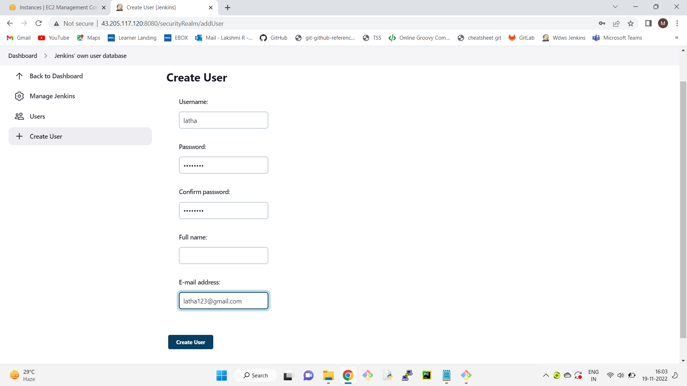

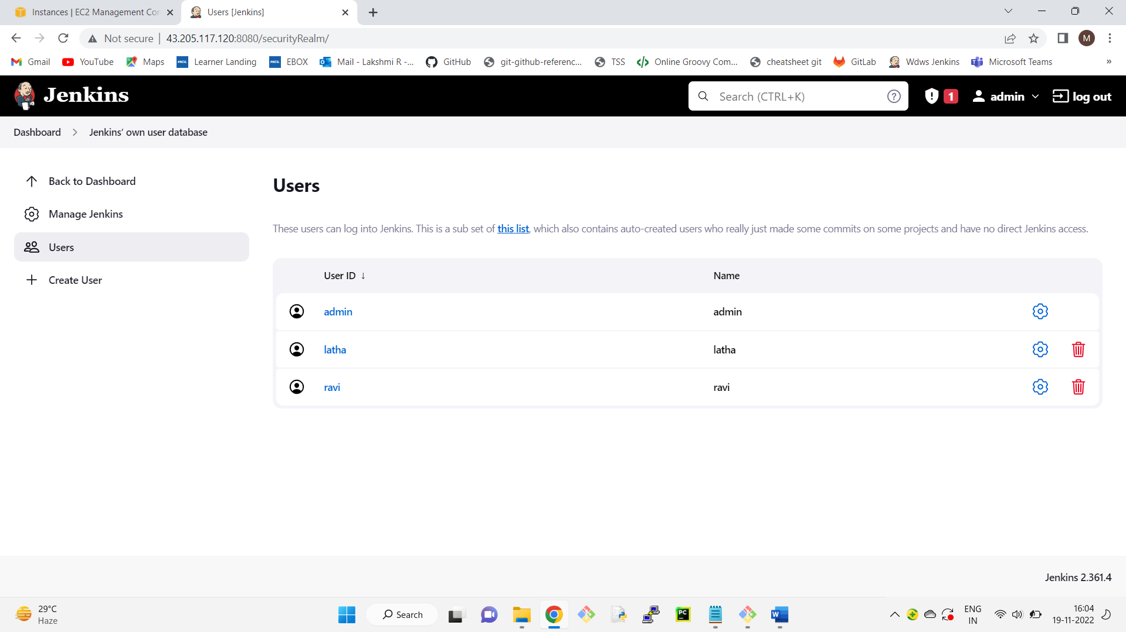

Creating roles and assgning

==============================

1 Install "role based authorization strategy" plugin

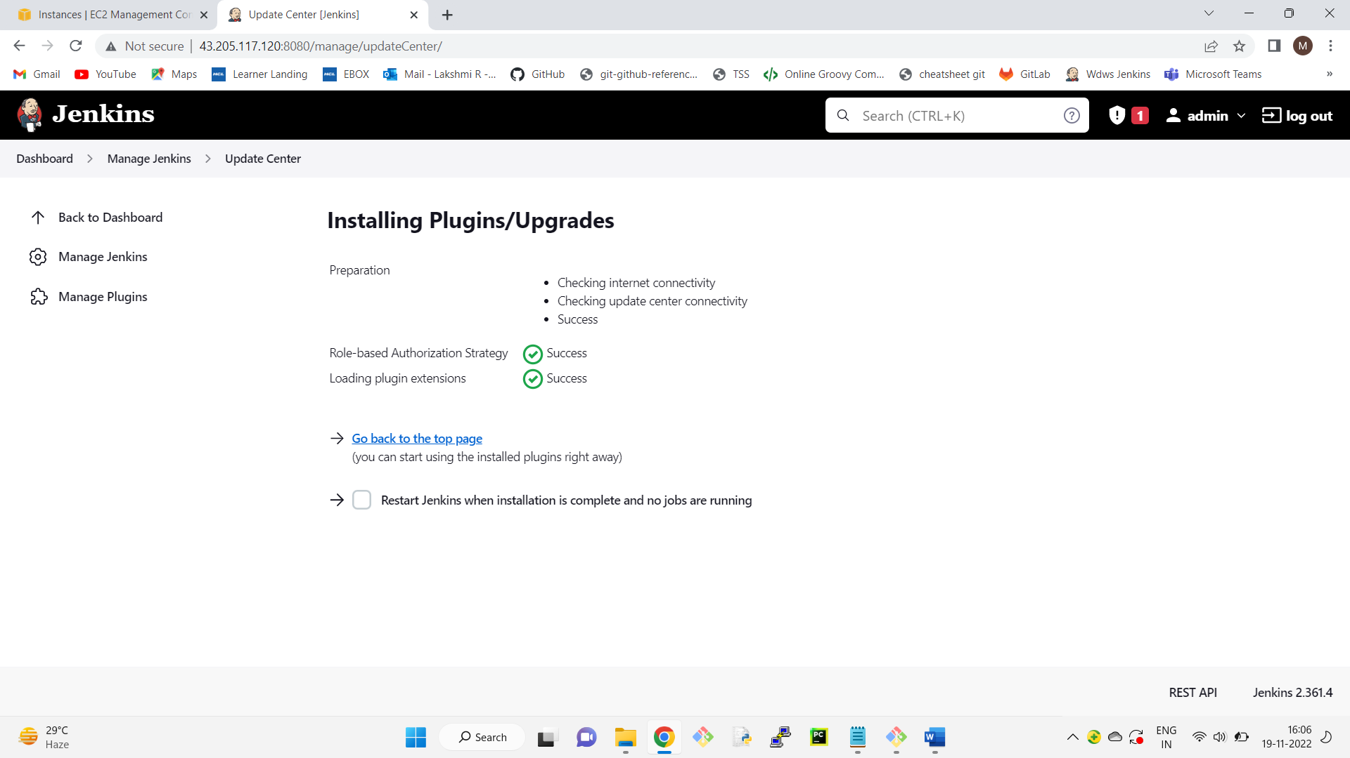

6 go to dashboard-->manage jenkins

7 click on configure global security

8 check enable security checkbox

9 go to authorization section-->click on role based strategy radio button

10 apply-->save

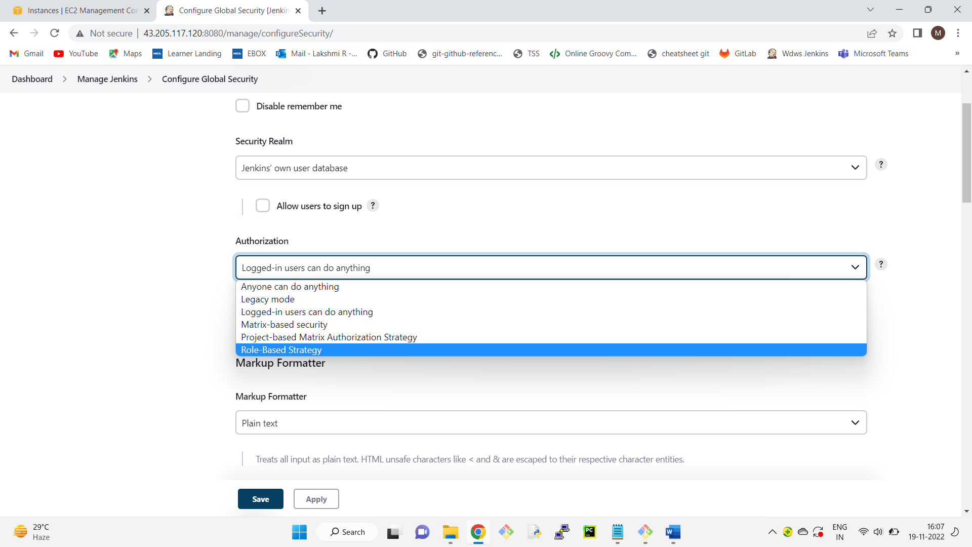

11 go to dashboard of jenkins

12 click on manage jenkins

13 click on manage and assign roles

14 click on mange roles

15 go to global roles and create a role "employee"

16 for this employee in overall give read access

in view section give all access

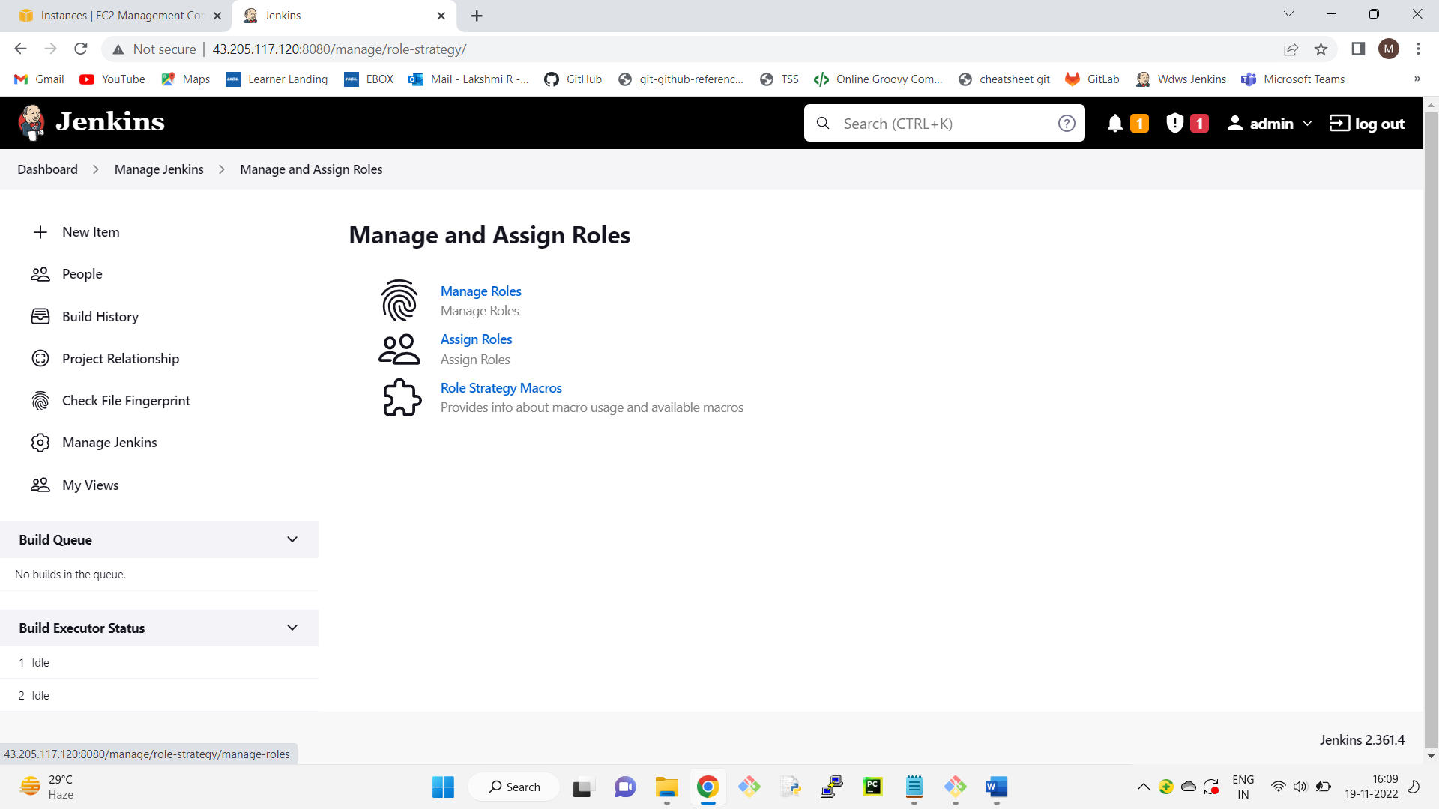

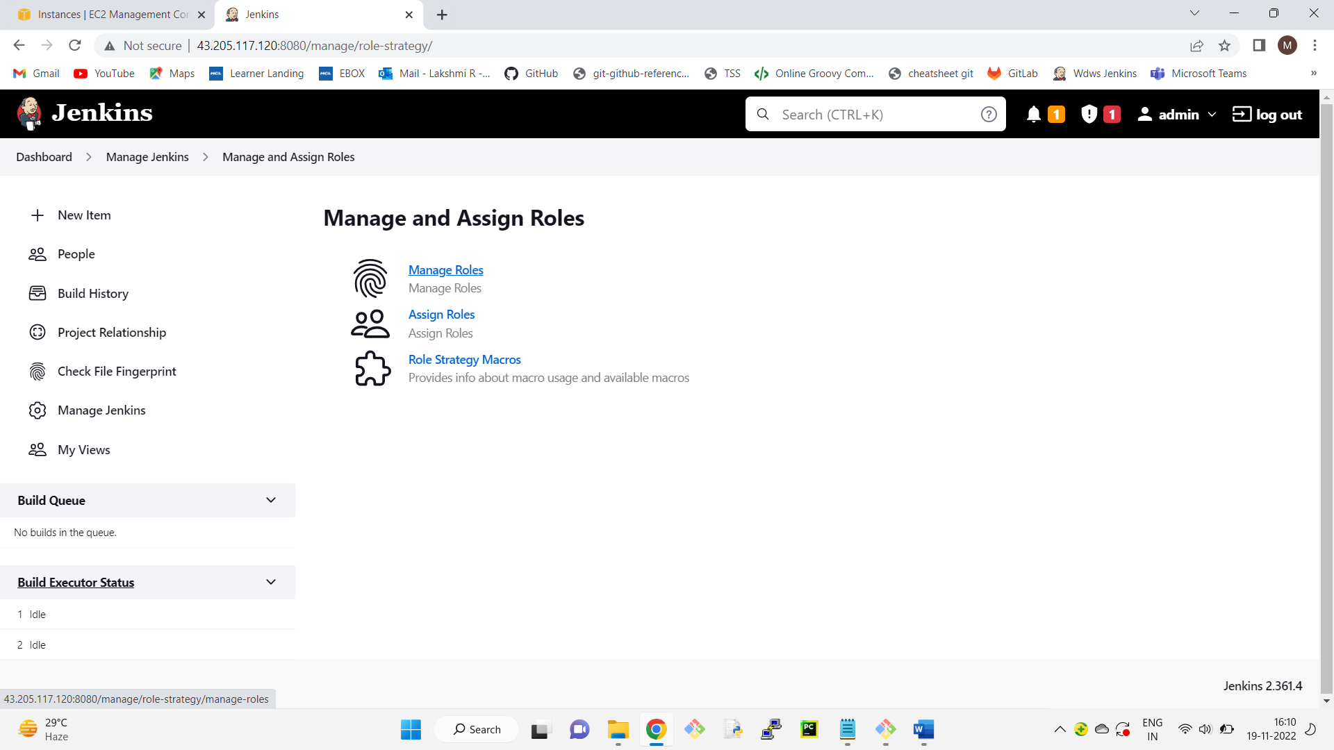

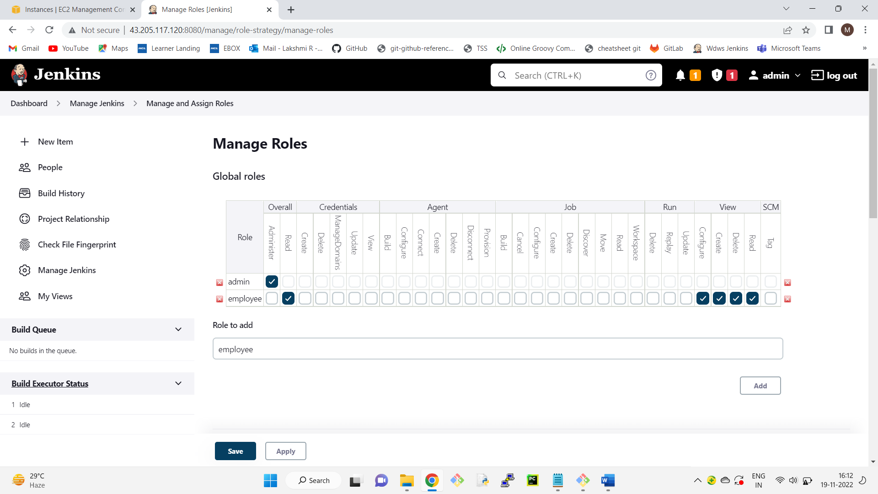

17 go to project roles-->Give the role as developer and patter as dev.* (ie developer role can access only those jobs whose name start with dev)

18 similarly create another role as tester and assign the pattern as "test.*"

19 give all permissions to developers and tester

20 apply—save

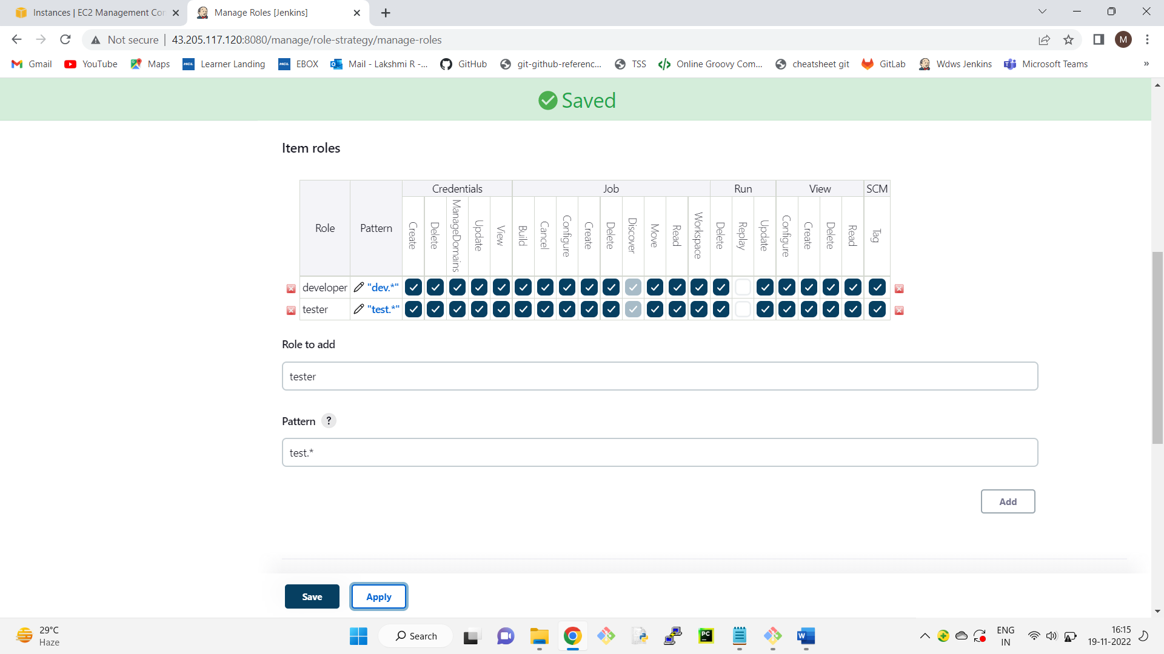

21 click on assign roles

22 go to global roles and add user1 and user2

23 check user1 and user2 as employees

24 go to item roles

25 add user1 and user2

26 check user1 as developer and user2 as tester

27 apply-->save

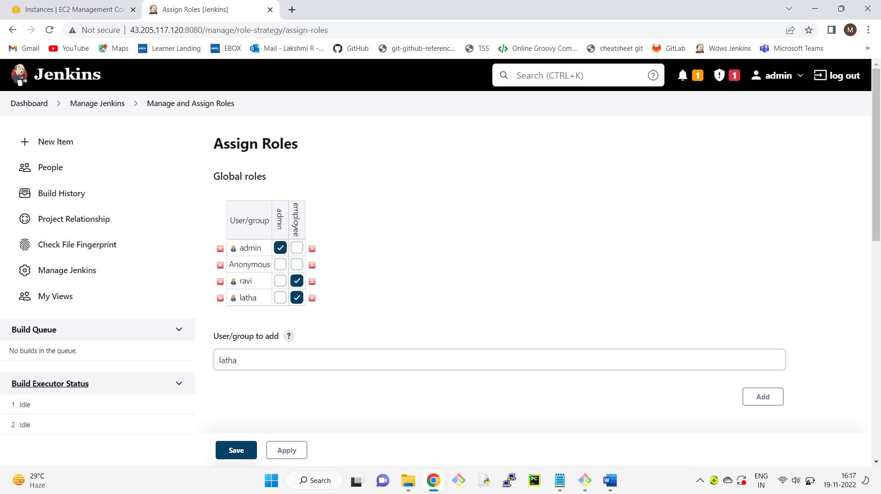

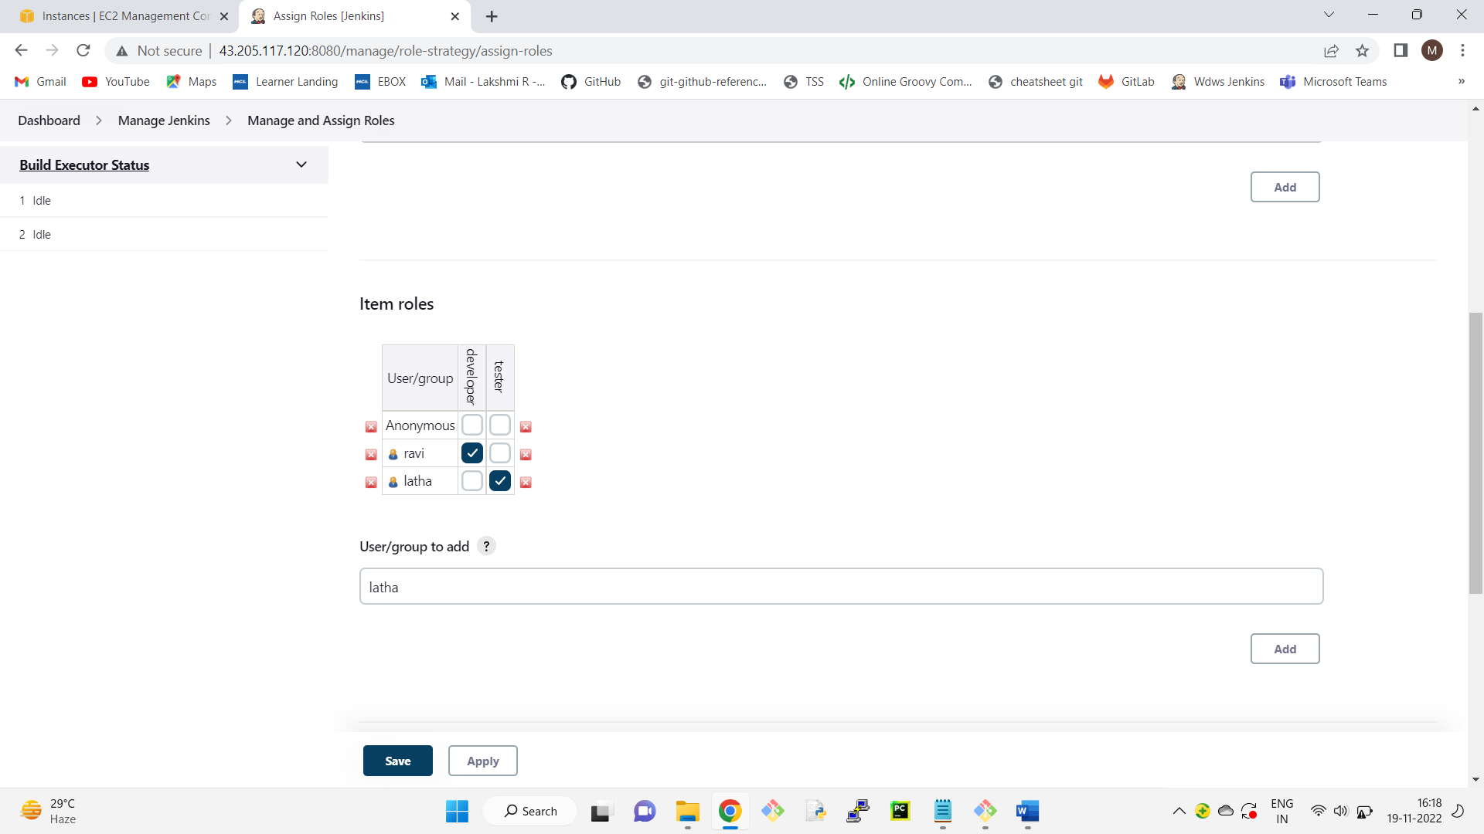

Restart Jenkins

http://13.233.127.59:8080/restart

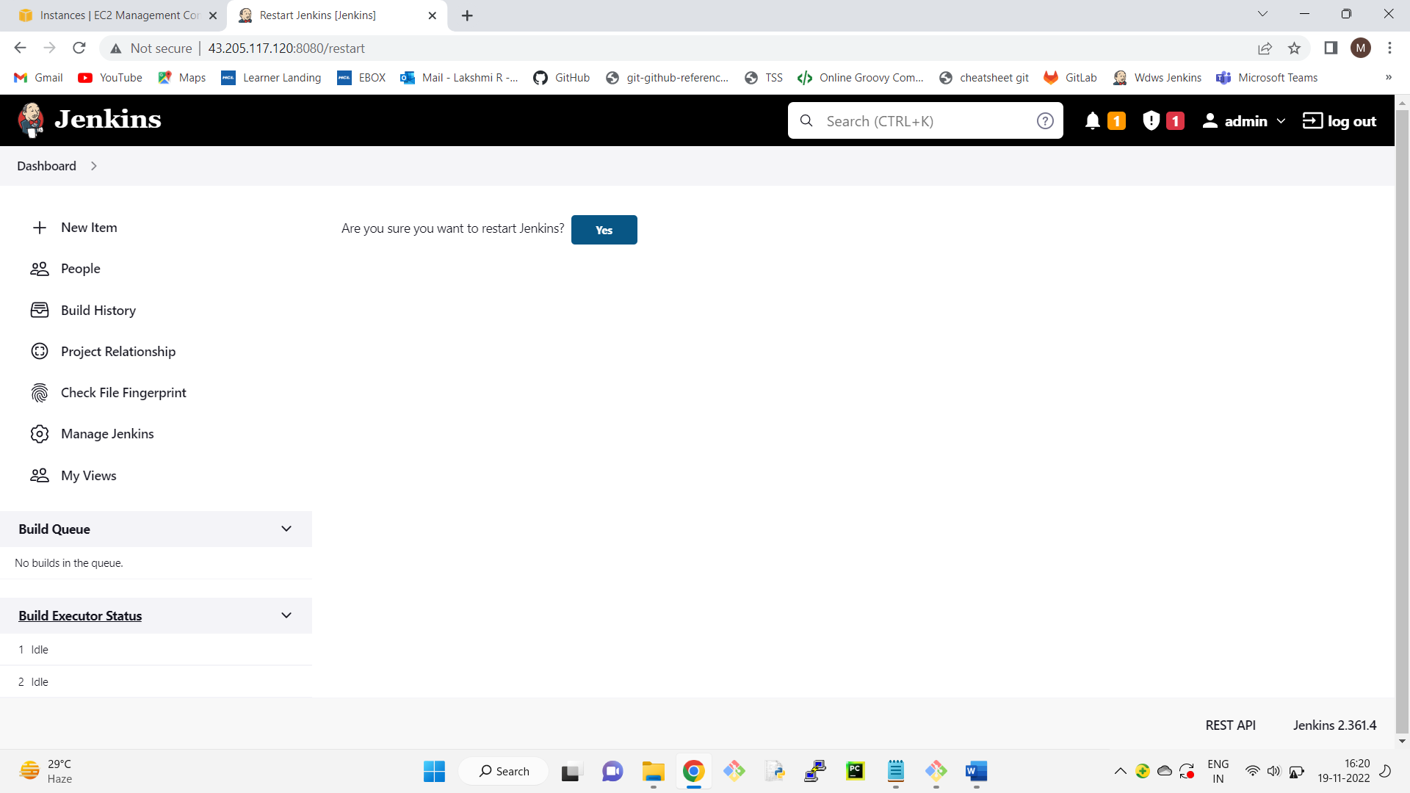

If we login into jenkins as user1 we can access on the development related jobs and user2 can access

only the testing related jobs

